**Angular Basics:**

in app.comp.ts

In app.comp.html

In test.comp.html



In test.comp.ts

Structural directives:

Html file:

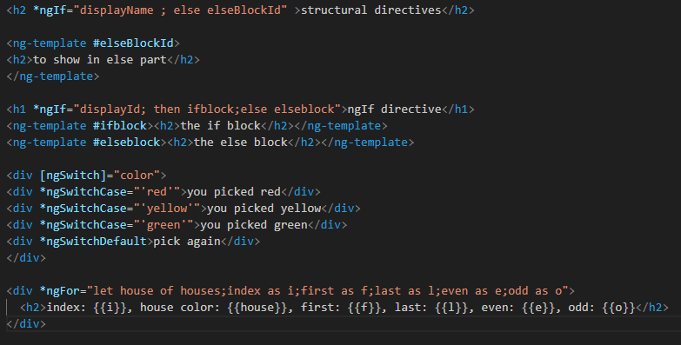

Ts file:

